MHD Omar Kabbani

000389376

**Q1:**

#include <stdio.h>

#include<stdlib.h>

#include<time.h>

int main()

{

int dice1, dice2, total;

srand(time(NULL));

dice1 = rand() %6 + 1;

dice2 = rand() %6 + 1;

total = dice1 + dice2;

if (total == 7 || total == 11){

printf("Player Wins \n Winner Winner Chicken Dinner");

}

else {

printf("First Dice is: %d \n",dice1);

printf("Second Dice is: %d \n",dice2);

printf("thank you for playing");

}

}

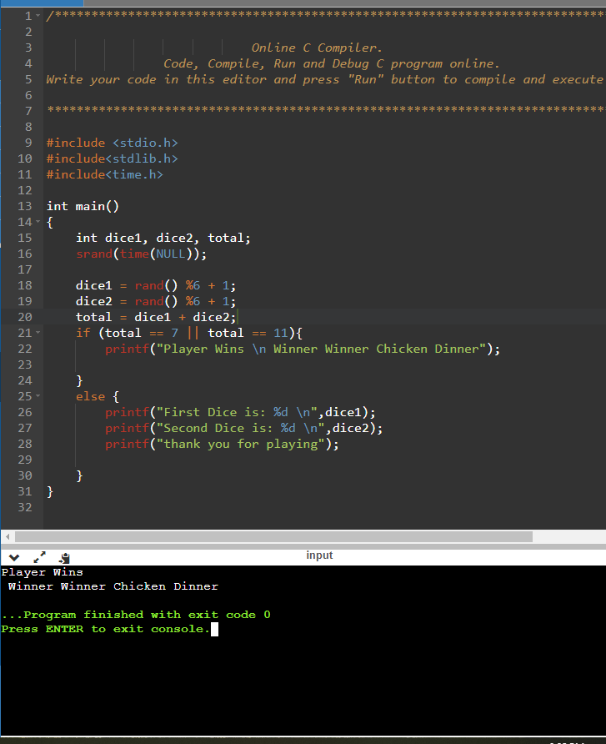

**Q2:**

#include<stdio.h>

#include<stdlib.h>

int main(){

int a[4],number,x;

printf("Enter Decimal number between 0 and 32: \n");

scanf("%d",&number);

if (number > 0 && number < 32){

for(x=0;number>0;x++)

{

a[x]=number%2;

number=number/2;

}

printf("Decimal to Binary=");

for(x=x-1;x>=0;x--)

{

printf("%d",a[x]);

}

}

else printf("out of range");

return 0;

}

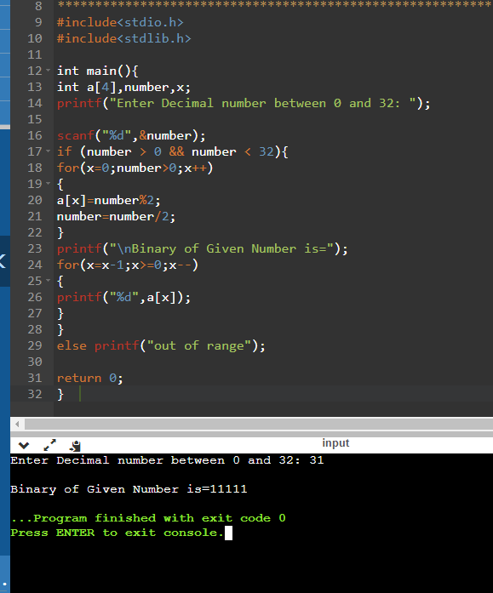

**Q3**

#include <stdio.h>

int main()

{

int number, count = 0;

printf("Enter an integer: ");

scanf("%d", &number);

do

{

count++;

number /= 10;

} while(number != 0);

printf("Number of digits: %d", count);

return 0;

}

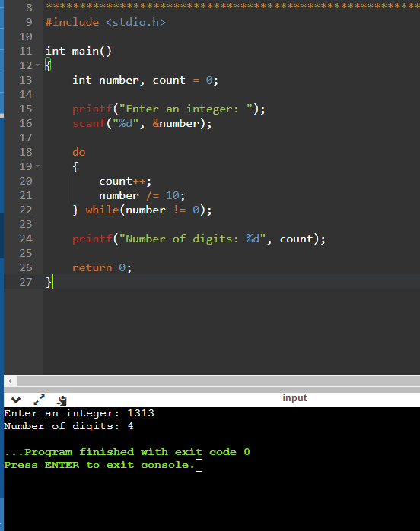

**Q4)**

#include<stdio.h>

int main(){

int choice;

int hamburger=0,hotdog=0,fries=0,drink=0,exit;

do {

printf("What do you want to eat today?\n");

printf("1. Hamburger\n");

printf("2. Hotdog\n");

printf("3. Drinks\n");

printf("4. Fries\n");

printf("5. Exit\n");

printf("Enter your choice: ");

scanf("%d", &choice);

switch(choice){

case 1:

printf("You ordered a hamburger\n");

hamburger++;

break;

case 2:

printf("You ordered a hotdog\n");

hotdog++;

break;

case 3:

printf("You ordered drinks\n");

drink++;

break;

case 4:

printf("You ordered fries\n");

fries++;

break;

case 5:

printf("Order finished, thank you!\n");

break;

default:

printf("Wrong choice! try again: ");

break;

}

} while (choice != 5);

int total = (hamburger5) + (hotdog4) + (fries3)+ (drink2);

float tax = 0.13 * total;

float grandtotal = tax + total;

printf("You ordered %d hamburger(s), %d hotdog(s), %d fries, %d drink(s). Price: $%d HST: $%.2f Total: $%.2f",hamburger,hotdog,fries,drink,total,tax,grandtotal);

return 0;

}

